Name: ______________________________________________________ Date: _____________________

McGill Instructions
In each category below Circle ONLY a single word that best describes your present pain. Leave out any category that is not suitable.
1. | 2. | 3. | 4. | 5. | 6.
Flickering | Jumping | Prickling | Sharp | Pinching | Tugging
Quivering | Flashing | Boring | Cutting | Pressing | Pulling
Pulsing | Shooting | Drilling | Lacerating | Gnawing | Wrenching
Throbbing |  | Stabbing |  | Cramping
Beating |  | Lancinating
Pounding
7. | 8. | 9. | 10. | 11. | 12.
Hot | Tingling | Dull | Tender | Tiring | Sickening
Burning | Itchy | Sore | Taut | Exhausting | Suffocating
Scalding | Smarting | Hurting | Rasping
Searing | Stinging | Aching | Splitting
 |  | Heavy
13. | 14. | 15. | 16. | 17. | 18.
Fearful | Punishing | Wretched | Annoying | Spreading | Tight
Frightful | Grueling | Blinding | Troublesome | Radiating | Numb
Terrifying | Cruel |  | Miserable | Penetrating | Drawing
 | Vicious |  | Intense | Piercing | Squeezing
 | Killing |  | Unbearable |  | Tearing
19. | 20.
Cool | Nagging
Cold | Nauseating
Freezing | Agonizing
 | Dreadful
 | Torturing
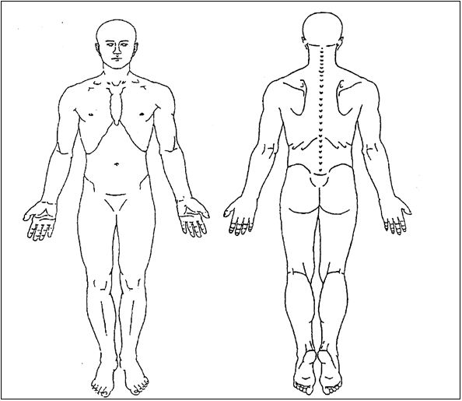
__________________________________________________________________________________________________
Please mark the drawings where you feel the following sensations ONLY related to your present injury or condition.

/// Stabbing

XXX Burning

000 Pins and Needles

=== Numbness

